SCHOOL

Semester One Examination, 2013

Question/Answer Booklet

MATHEMATICS 2C
SOLUTIONS

Section Two:

Calculator-assumed

Student Number: In figures

In words

Your name

Time allowed for this section
Reading time before commencing work: ten minutes
Working time for this section: one hundred minutes

Materials required/recommended for this section

To be provided by the supervisor
This Question/Answer Booklet
Formula Sheet (retained from Section One)

To be provided by the candidate
Standard items: pens, pencils, pencil sharpener, eraser, correction fluid/tape, ruler, highlighters

Special items: drawing instruments, templates, notes on two unfolded sheets of A4 paper, and up to three calculators satisfying the conditions set by the Curriculum Council for this examination.

Important note to candidates

No other items may be used in this section of the examination. It is your responsibility to ensure that you do not have any unauthorised notes or other items of a non-personal nature in the examination room. If you have any unauthorised material with you, hand it to the supervisor before reading any further.

Structure of this paper

Section | Number of questions available | Number of questions to be answered | Working time (minutes) | Marks available | Percentage of exam
Section One:  Calculator-free | 6 | 6 | 50 | 50 | 33
Section Two:  Calculator-assumed | 12 | 12 | 100 | 100 | 67
 |  |  | Total | 150 | 100

Instructions to candidates

- The rules for the conduct of Western Australian external examinations are detailed in the Year 12 Information Handbook 2013. Sitting this examination implies that you agree to abide by these rules.

- Write your answers in the spaces provided in this Question/Answer Booklet. Spare pages are included at the end of this booklet. They can be used for planning your responses and/or as additional space if required to continue an answer.
- Planning: If you use the spare pages for planning, indicate this clearly at the top of the page.
- Continuing an answer: If you need to use the space to continue an answer, indicate in the original answer space where the answer is continued, i.e. give the page number. Fill in the number of the question(s) that you are continuing to answer at the top of the page.

- Show all your working clearly. Your working should be in sufficient detail to allow your answers to be checked readily and for marks to be awarded for reasoning. Incorrect answers given without supporting reasoning cannot be allocated any marks. For any question or part question worth more than two marks, valid working or justification is required to receive full marks. If you repeat an answer to any question, ensure that you cancel the answer you do not wish to have marked.

- It is recommended that you do not use pencil, except in diagrams.

Section Two: Calculator-assumed (100 Marks)
This section has twelve (12) questions. Answer all questions. Write your answers in the spaces provided.

Working time for this section is 100 minutes.

Question 7 (6 marks)
When a house is sold in Western Australia, there is usually a duty (or tax) payable to the State Government when the sale is finalised. The current rates are shown in the table below.

Value of house | Duty payable
$0 - $120 000 | $1.90 per $100 or part thereof
$120 001 - $150 000 | $2 280 + $2.85 per $100 or part thereof above $120 000
$150 001 - $360 000 | $3 135 + $3.80 per $100 or part thereof above $150 000
$360 001 - $725 000 | $11 115 + $4.75 per $100 or part thereof above $360 000
$725 001 and upwards | $28 453 + $5.15 per $100 or part thereof above $725 000

(a) If a house is valued at $535 000, how much duty is payable when it is sold? (3 marks)

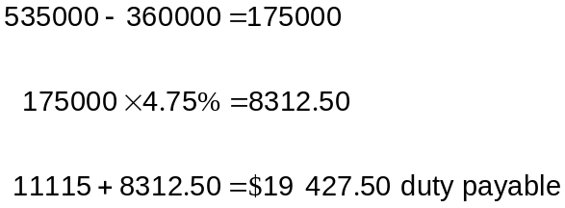

(b) For a person buying their first home, the duty payable is reduced and is calculated using the rates in this table:

Value of house | Duty payable
$0 - $500 000 | Nil
$500 000 - $600 000 | $22.51 per $100 or part of $100 above $500 000

How much does a first home buyer save on duty if they buy a house valued at $535 000?
(3 marks)
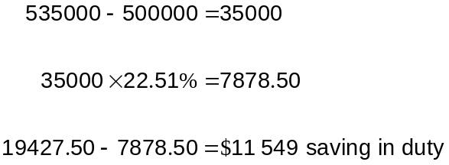

Question 8 (9 marks)
A group of 108 students were categorised as male or female and left handed or right handed. In the group, one-twelfth of all students were left handed, there were two more females than males, and there were 51 right handed females.

(a) Complete this table to summarise the above information. (4 marks)

 | Male | Female | Total
Left handed | 5 | 4 | 9
Right handed | 48 | 51 | 99
Total | 53 | 55 | 108

(b) How many of the students are male or left handed? (1 mark)

5 + 48 + 4 = 57

(c) What is the probability that a student randomly chosen from the group is

(i) female? (1 mark)
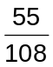

(ii) a right handed male? (1 mark)
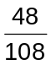

(iii) not a left handed female? (1 mark)
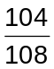

(iv) right handed, given that they are female? (1 mark)
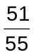

Question 9 (9 marks)
(a) A car dealer advertises two ways to buy a car priced at $15 900. The first is to pay a 5% deposit on the day of purchase and then make monthly payments of $495 for the next three years. The second is to simply pay the cash price of $15 900.

(i) How much is 5% of $15 900? (1 mark)
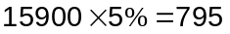

(ii) How many monthly repayments must be made using the first method? (1 mark)
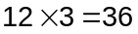

(iii) Which is the least expensive way to buy the car, and by how much? (3 marks)
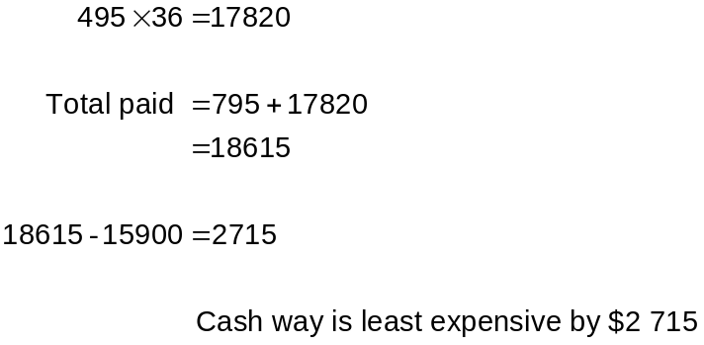

(b) Cars tend to depreciate in value by 20% per year.

What would the value of a $15 900 car be, to the nearest $100, after

(i) one year? (2 marks)
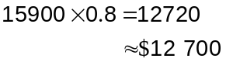

(ii) five years? (2 marks)
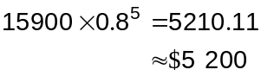

Question 10 (12 marks)
Part of a fitness test involves jumping as high as possible from a squatting position. The difference between the height reached in the jump and the jumper's height is recorded.

The best jumps for 24 people are shown below in centimetres.

41.6 | 39.2 | 31.9 | 41.5 | 34.7 | 50.1 | 48.6 | 36.4
34.4 | 41.1 | 40.3 | 42.7 | 34.9 | 40.8 | 47.1 | 34.8
42.6 | 27.6 | 48.2 | 45.3 | 39.0 | 36.9 | 28.2 | 48.2

(a) Calculate the range for the above jumps. (1 mark)

Range = 50.1 - 27.6 = 22.5 cm.

(b) Complete the grouped frequency table below for the jumps. (3 marks)

Jump (cm) | Tally | Frequency
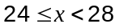 |  | 1
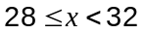 |  | 2
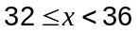 |  | 4
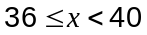 |  | 4
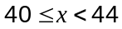 |  | 7
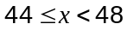 |  | 2
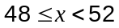 |  | 4

(c) State the modal class. (1 mark)

Modal class is cm

(d) Calculate the mean of the jumps using the grouped data. (2 marks)
Mean is 40 cm.

(e) Construct a frequency histogram for the grouped data. (3 marks)

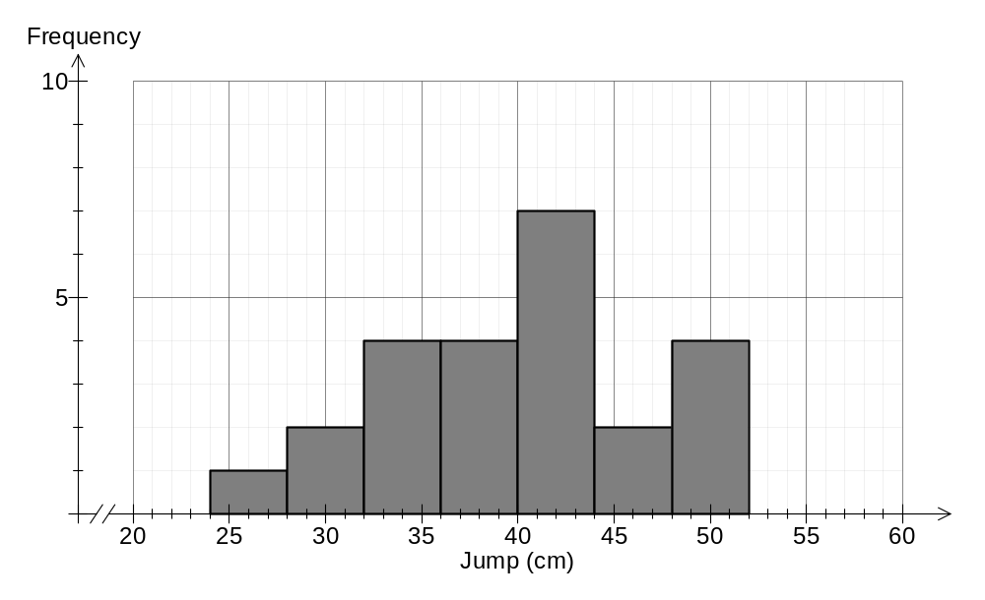

(f) Does the histogram suggest that there are one or more outliers in this data? Explain your answer. (2 marks)
No. There are no points that appear to be a long way from the bulk of the data.

Question 11 (8 marks)
The straight line with equation 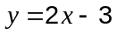 is shown below.
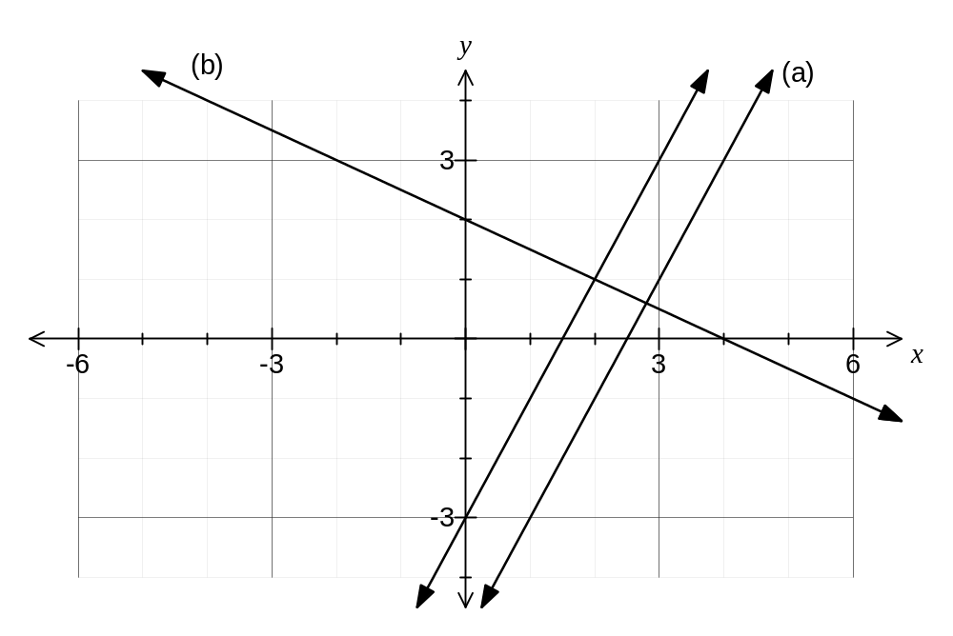

(a)
(i) Draw on the axes above, the line parallel to that passes through the point A(3, 1). Label this line (a). (2 marks)

(ii) Find the equation of the parallel line drawn in part (i). (2 marks)
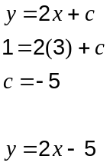

(b)
(i) Draw on the axes above, the line perpendicular to that passes through the point B(0, 2). Label this line (b). (2 marks)

(ii) Find the equation of the perpendicular line drawn in part (i). (2 marks)
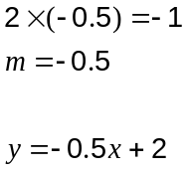

Question 12 (5 marks)
The following recursive formula is used to calculate the value of $10 000 after years when compound interest of 4% is added annually:

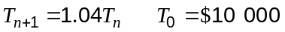

(a) Find 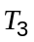. (1 mark)
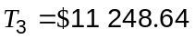

(b) How much interest will be added to the $10 000 after one year? (1 mark)

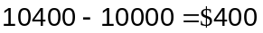

(c) How many years must pass before the $10 000 has doubled in value? (1 mark)

18 years

(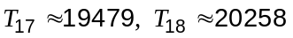)

(d) Write a recursive formula to calculate the value of $400 after years when compound interest of 10% is added annually. (2 marks)
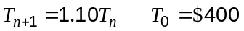

Question 13 (9 marks)
Match each data set below with one of the mean, median or mode as a suitable measure for indicating central location. Use each measure once only, calculate the measure and explain an advantage of your choice.

(a) (3 marks)
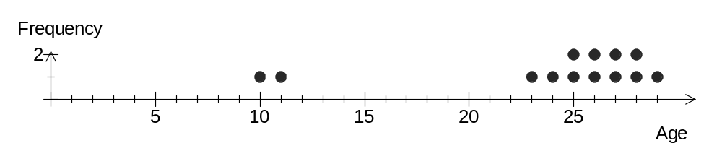
Median = 26

Advantage: Not influenced by the two outliers.

(b) (3 marks)
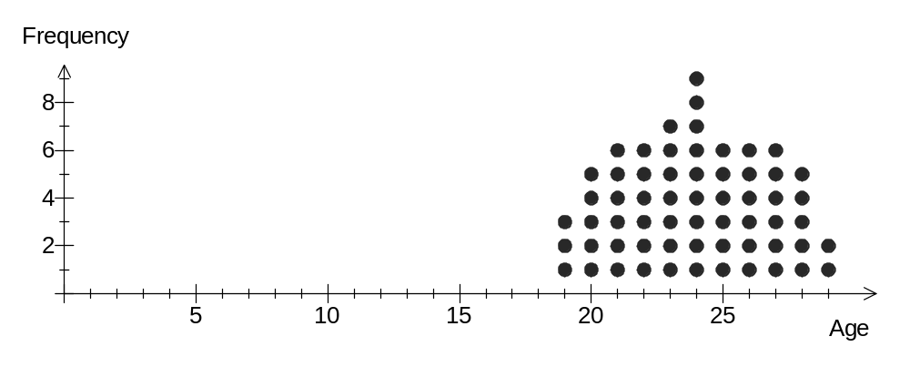
Mode = 24

Advantage: Quick to find for such a large number of scores.

(c) (3 marks)
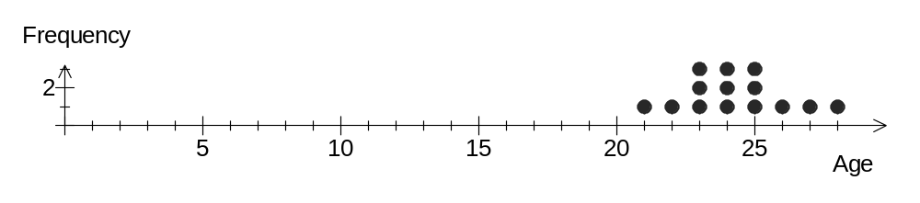
Mean = 24.3

Advantage: All scores are used to calculate the mean and hence are reflected in its value.

Question 14 (9 marks)
At an airport, suitcases are moved from the terminal T to the loading bay X through a system of conveyor belts. The network below displays the maximum number of suitcases per minute that the system can move between the various junctions.

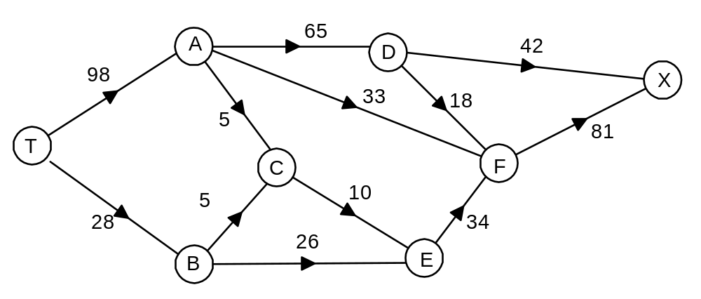

(a) What is the maximum number of suitcases that can be moved from the terminal T to the loading bay X in one hour? Show systematic working to allow your solution to be checked.
(6 marks)
TADX: 42
TADFX: 18
TAFX: 33
TACEFX: 5
TBCEFX: 5
TBEFX: 20

Total: 123 per minute.

Hence a maximum of 7 380 suitcases in one hour.

(b) The capacity of one conveyor belt can be increased by 10 suitcases per minute. What effect would this have on the maximum flow if the conveyor belt chosen was

(i) between T and B? (1 mark)
No change.
(This section already has spare capacity)

(ii) between F and X? (2 marks)
An increase of 3 suitcases per minute.
(Along the path TBEFX)

Question 15 (9 marks)
A small group of sixteen university students took part in two experiments to determine whether any relationship existed between the skills measured in each experiment. The student's scores in each experiment are shown on this scatterplot.
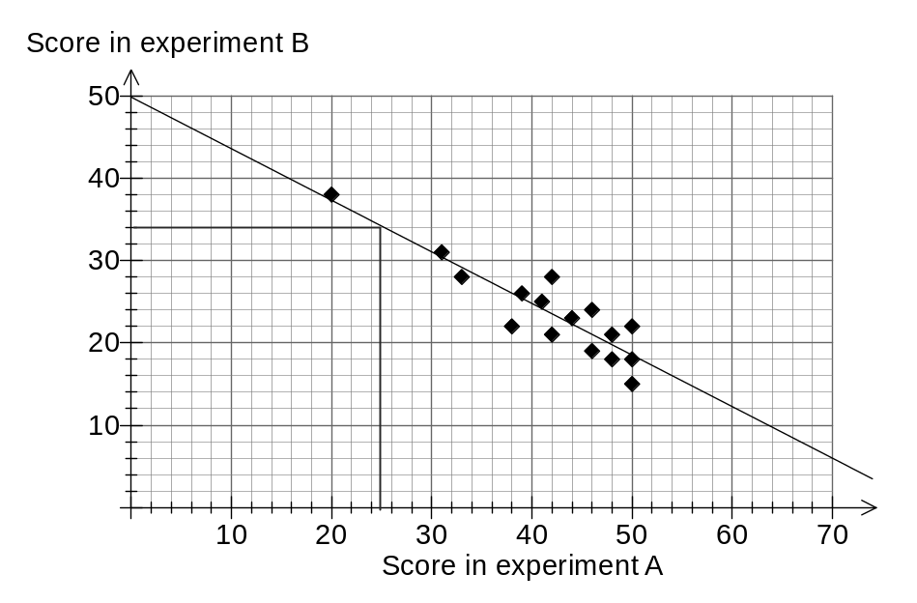

(a) What was the lowest score achieved by a student in experiment B? (1 mark)
15

(b) What was the highest total achieved by a student when their scores for both experiments are added together? (2 marks)
50 + 22 = 72

(c) Draw a trend line on the scatterplot 'by eye'. (2 marks)

(d) Another student achieved a score of 25 in experiment A but did not have time to do experiment B.

(i) Use your trend line to predict the score in experiment B for this student, clearly showing your method on the graph. (2 marks)
34

(ii) Does your prediction in (i) use interpolation or extrapolation? Explain your answer.
(2 marks)
Interpolation, as the score in experiment A used for the prediction (25) is within the range of scores in experiment A used to create the scatterplot (from 20 to 50).
Question 16 (7 marks)
In a BMX jumping competition, riders are given a score out of ten for each of the three parts of a jump they perform - the approach, the flight and the landing.

Three riders, Andy, Ben and Chris, remain in a competition and their scores for each part of the first jump they perform are given in this table:

Rider | Approach | Flight | Landing
Andy | 7 | 7 | 6
Ben | 5 | 8 | 5
Chris | 4 | 9 | 6

(a) Determine an overall average score out of ten for the first jump of each rider and hence state who had the best jump in the first round. (3 marks)

Andy: 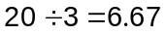

Ben: 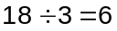

Chris: 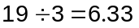

Andy had best jump

(b) The judges were considering a new scoring system for the competition, in which the score for the flight was three times as important as the approach and the score for the landing was twice as important as the approach.

Determine the weighted score for each of the above riders for their first jump, and comment on whether the new scoring system would affect the choice of best jumper.
(4 marks)
Andy:

Ben:

Chris:

Chris is now the best jumper, so new system does change result.

Question 17 (10 marks)
A questionnaire answered by 317 members of a motoring organisation showed that 298 held a licence to drive a car (set C), 63 held a licence to drive a motorbike (set M) and 3 held neither licence.

(a) Complete the Venn diagram below to show this information. (3 marks)
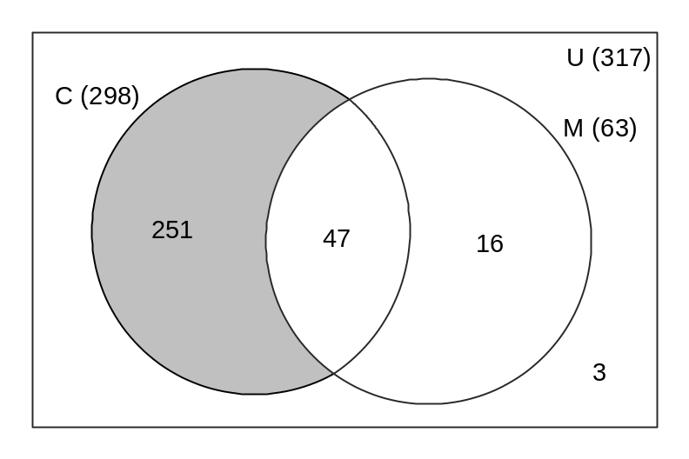
(b) Describe, in words, the members of the set 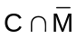 and shade this region on the diagram above. (2 marks)
Members who have a car licence but not a motorbike licence.

(c) Determine 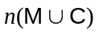. (1 mark)
314

(d) If one member is chosen at random, determine

(i) 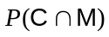 (2 marks)
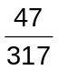

(ii) 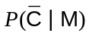 (2 marks)
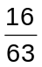

Question 18 (7 marks)
On a map, two mines are located with coordinates A(230, 335) and B(-60, 190) relative to a small town at T(0, 0). Distances are given in kilometres.
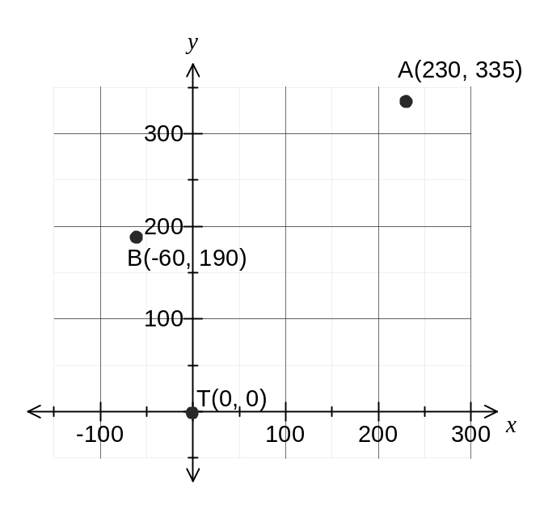
(a) Calculate the distance between the two mines. (3 marks)
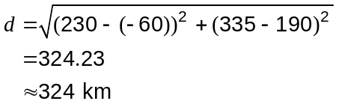

(b) If the equation of the straight line through the mines at A and B is 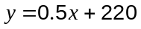, explain whether or not a third mine at C(80, 240) lies on this line. (2 marks)
No - by substitution of point C:

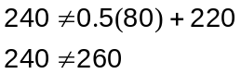

(c) A fourth mine has coordinates D(230, ) and is 60 km away from A. Determine all possible value(s) of . (2 marks)
D lies on the line 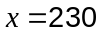. So

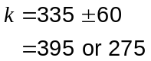

This examination paper may be freely copied, or communicated on an intranet, for non-commercial purposes within educational institutes that have purchased the paper from WA Examination Papers provided that WA Examination Papers is acknowledged as the copyright owner. Teachers within purchasing schools may change the paper provided that WA Examination Paper's moral rights are not infringed.

Copying or communication for any other purposes can only be done within the terms of the Copyright Act or with prior written permission of WA Examination papers.

Published by WA Examination Papers
PO Box 445 Claremont WA 6910

